AI USAGE FOR PROJECT
Data Acquisition
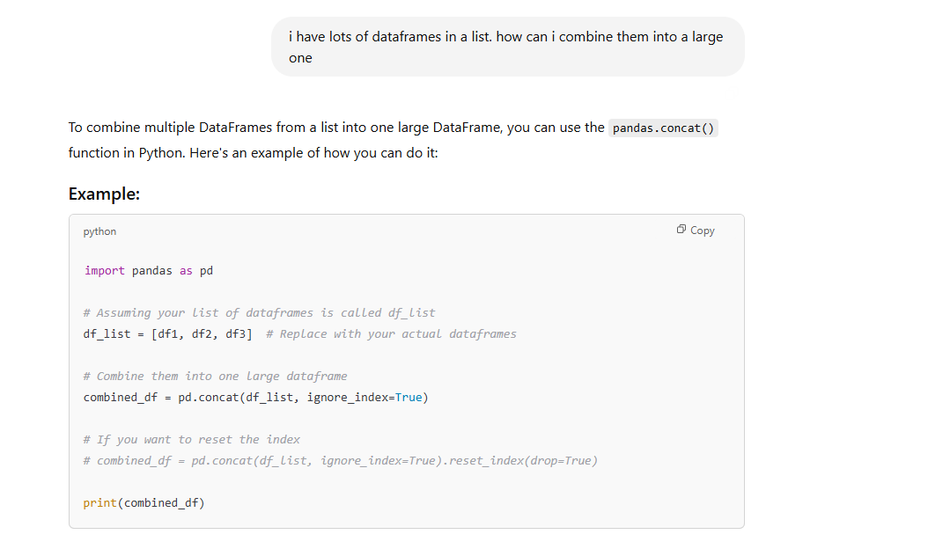
Used the concat function. Printed the df and it was in the format as I had downloaded as pdf but now as a df, the data matched, except from there were float entries instead of integers. This will not affect visualisation. If we want to display the data we can later convert it into integers

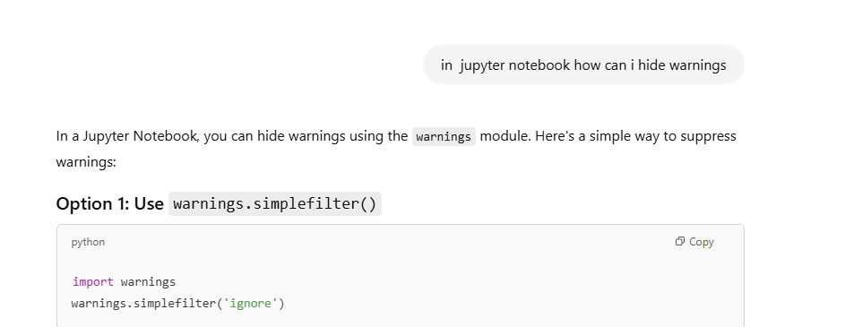
Wanted to remove redundant warning errors when using the module tabula

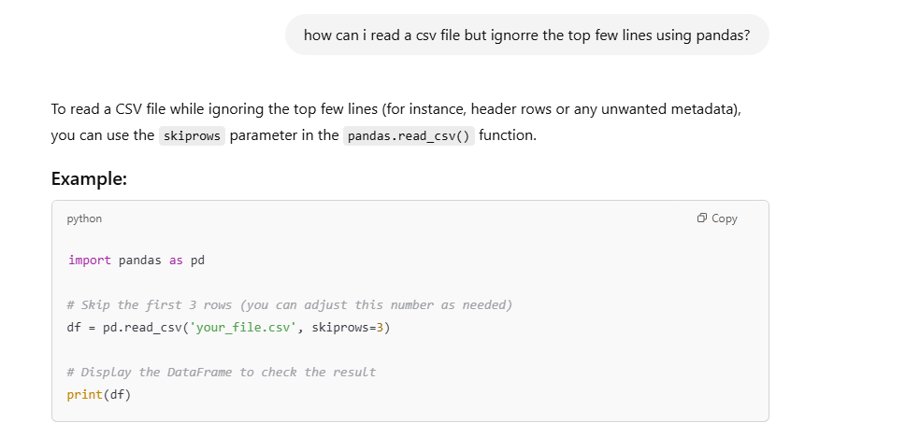
The data I had was a csv file with some text on top so I wanted to skip these rows. Now the code actually ran and there was no text on top like the csv file in the data folder

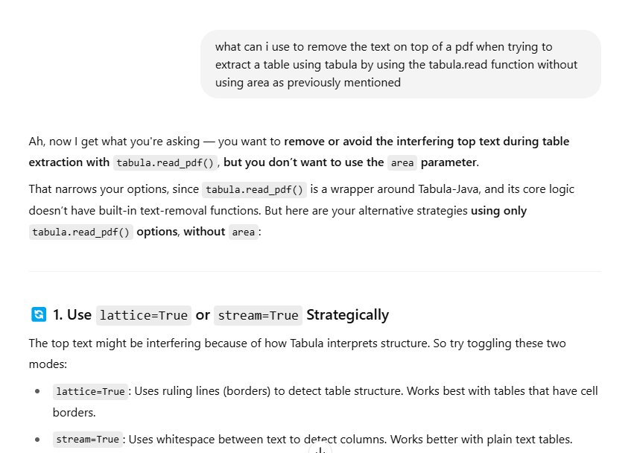
I needed a way to remove the text from the top. It told me before to use area which I did not want to do as I would have to locate the area in which the table was located. I used both lattice and stream and printed the output. Lattice did not help so I used stream, and this removed the text on top.

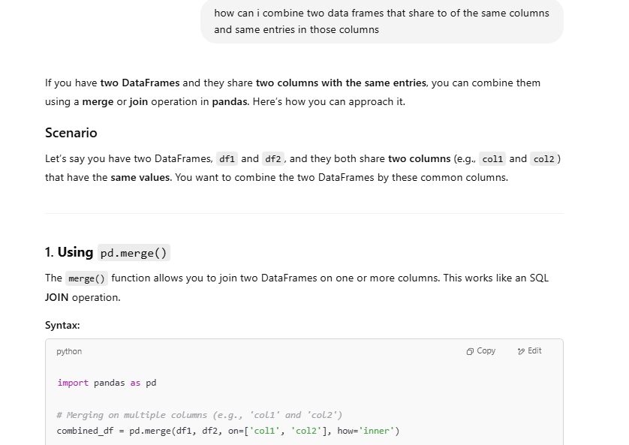
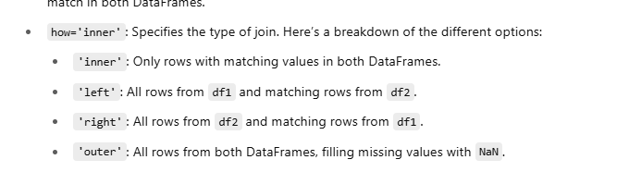
This didn’t work, but I used how = “outer” and it worked.

